Dear Girls,
As you are aware your teachers will be delivering many of your lessons via Microsoft teams until your group is back in school. Please take the time to read this letter which outlines how you can access the lessons and sets out what you need to do.
Teams Lessons
- Teachers will notify you about a Teams lesson using Firefly.
- All students are expected to attend the lesson just as with on site school lessons. A register will be taken for live Teams lessons. If you are unwell and unable to attend the lesson your parent will need to let school know just as they would for an absence normally.
- You must login only via your school 365 account and use the link from your Outlook page which has your school emails on. Any pupil trying to join via another route will appear as a guest to the teacher and will be blocked from the meeting.
- All student cameras have been set to off for these lessons.

- Please mute your microphone unless you are actively contributing to the lesson so that the sound quality is maximised.
- Distance learning requires teachers and pupils to adapt normal classroom routines to the online world, but our normal high expectations of behaviour remain.
- It is expected that pupils will engage in lessons in a manner as similar to regular classroom learning as possible. You should have all of your equipment ready before the lesson.
- Behaviour when working as part of an online lesson will be as expected in normal classroom learning: quietly attentive; prepared to ask and answer academic questions; engage actively with the lesson, whatever the challenge; and showing respect for others.
- The recording of still images, filmed images or audio of staff or other pupils without permission, and the distribution of such images, is strictly forbidden.
- Anyone who is not present should not be talked about.
- Please make sure that there is no background noise or disruption.

Please use the following guide in order to access the Teams lessons:
- Make sure that you are using use Edge or Chrome as other browsers either will not work or won’t have access to all features. For mobile devices the Teams app may be required in order to access the meetings, please ensure you use your school email address and password when signing into this.
- Login to your school account as normal via RM Unify and go to your emails page (Outlook)
- In the top left of the screen click the Apps icon and select Teams.

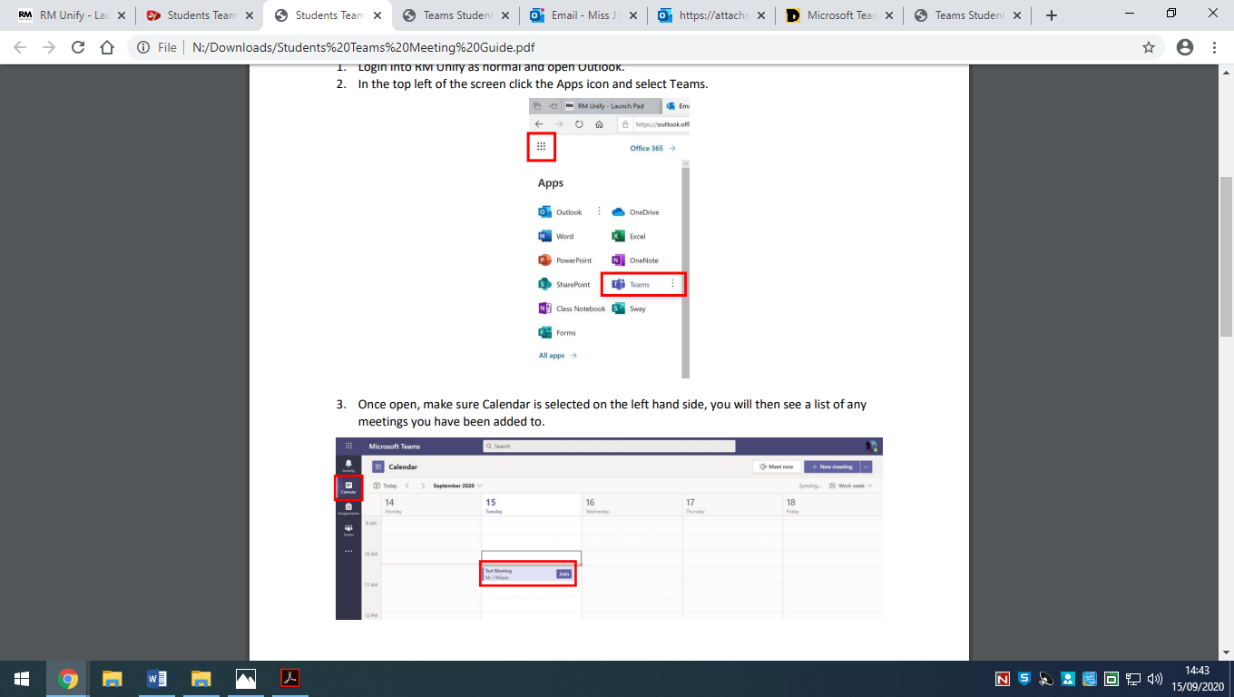
- Make sure Calendar is selected on the left hand side, you will then see a list of any meetings you have been added to.
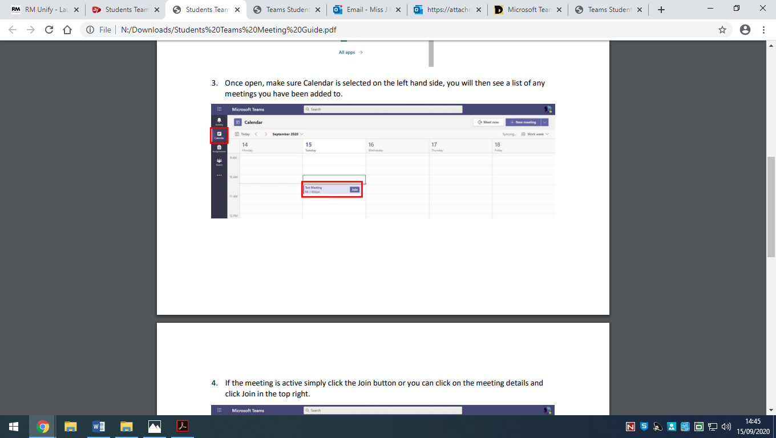
- If the meeting is active simply click the Join button or you can click on the meeting details and click Join in the top right.
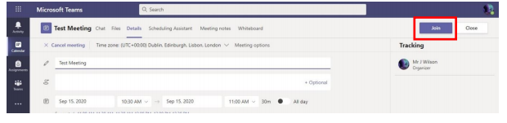

- An alternative route is to go via your outlook Outlook Calendar by logging in into RM Unify as normal and opening Outlook. Then click on the Calendar icon in the bottom left. This will bring up your calendar, with all the meetings you have been added too.
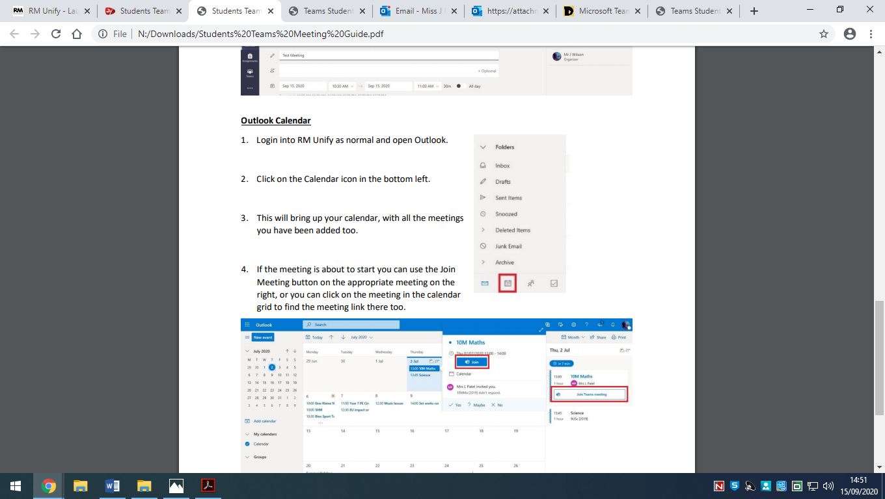
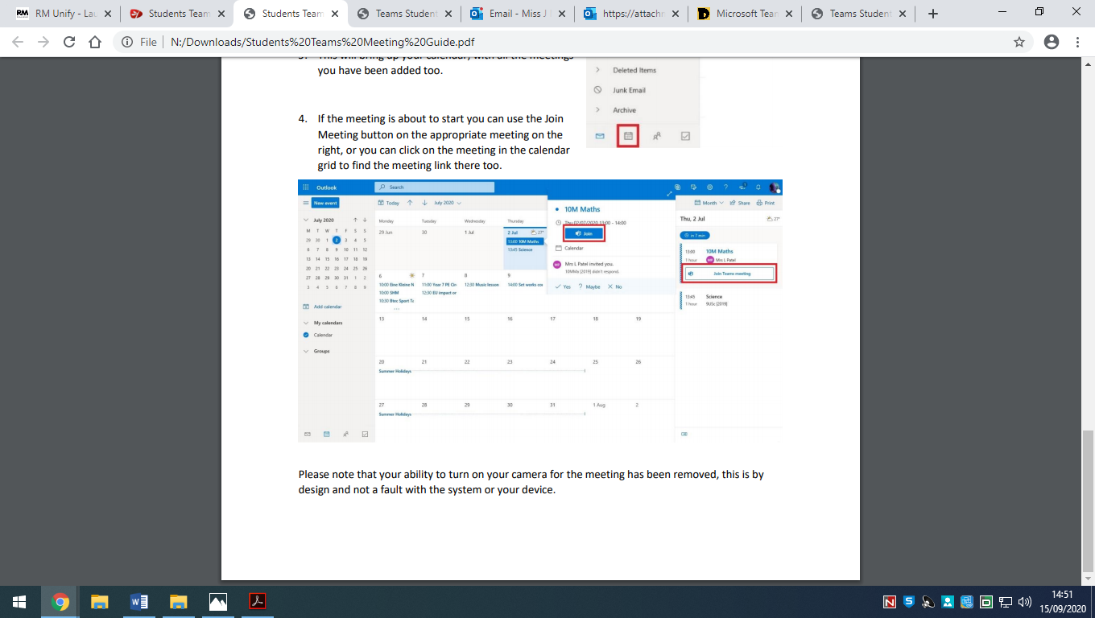
- If the meeting is about to start you can use the Join Meeting button on the appropriate meeting on the right, or you can click on the meeting in the calendar grid to find the meeting link there too.
- Please note that your ability to turn on your camera for the meeting has been removed, this is by design and not a fault with the system or your device.
If you are having any IT issues please email our IT T team on externalict@stpaulgl.bham.sch.uk
Do also remember to download the Firefly app if you have not already done so if you are trying to work on your phone as this might make viewing work on Firefly easier. The school code is STPAULGL
We have every confidence in you girls and we look forward to seeing you back in school soon.
Miss Mason

