16 November 2020

Dear Year 10 Parents/Carers
I regret to inform you that a Year 10 pupil who attended school has tested positive for COVID-19. The last day at school for the pupil, who subsequently had a positive test was Friday 13 November. We are advised that Year 10 can return to school on Monday 30 November 2020, which is 14 days after the pupil attended school.

On the advice from Public Health England, please note the following:
• The rest of the household does not need to isolate unless anyone develops symptoms, so this means any siblings that are not in Year 10 can still come to school.
• If your child or anyone else in the household develops symptoms of COVID-19 (high temperature, continuous cough, loss of taste/smell) you should all isolate and they should get tested.
• If you do not have symptoms, you do not need to get a test.
• If anyone in the household tests positive for COVID-19, they should isolate for 10 days from the onset of symptoms and everyone else in the household should isolate for 14 days.
Your daughter should follow her normal timetable for Teams lessons/Firefly as of tomorrow. We will be taking registers for all lessons, so if there is any reason for your daughter not attending the Teams lesson, please email Miss McCauley lmcauley@stpaulgl.bham.sch.uk. The guidance on how to log on and access Teams is attached.

This decision has not been taken lightly; your daughter’s health, education and wellbeing remain our highest priority. Sorry for the inconvenience that this will cause, however the guidance is clear.

Should your daughter have any queries regarding work, please contact Miss McCauley or her teachers on their email address.
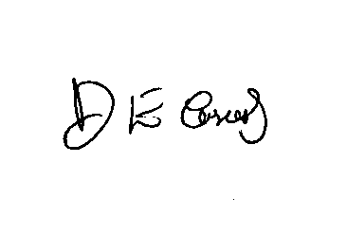
Yours sincerely

Dr D.E Casserly
Headteacher

