14 September 2020

Dear Year 10 Parents/Carers
I regret to inform you that a Year 10 pupil who has attended school has tested positive for COVID-19. Following the advice from Public Health England, you must not send your daughter into school tomorrow. She must remain isolated and can return to school on Thursday 24 September.

On the advice from Public Health England, please note the following:

• The rest of the household does not need to isolate unless anyone develops symptoms, so this means any siblings that are not in Year 10 can still come to school.
• If your child or anyone else in the household develops symptoms of COVID-19 (high temperature, continuous cough, loss of taste/smell) you should all isolate and they should get tested.
• If you do not have symptoms, you do not need to get a test.
• If anyone in the household tests positive for COVID-19, they should isolate for 10 days from the onset of symptoms and everyone else in the household should isolate for 14 days.
This decision has not been taken lightly; your daughter’s health, education and well-being remain our highest priority. Sorry for the inconvenience that this will cause, however the guidance is clear. When or if further information becomes available, we will inform you.

We will be providing work for your daughter tomorrow on Firefly. Should your daughter have any queries regarding work, please contact Miss McCauley or her teachers on their email address.
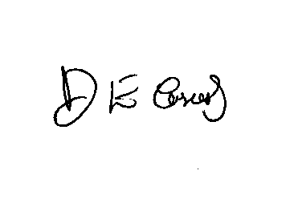
Yours sincerely

Dr D.E Casserly
Headteacher

