Dear Parents,

I hope you and your family are well despite all the stress and worry of the recent cancellation of your daughter’s exams.
The Government today said that “OFQUAL will develop and set out a process that will provide a calculated grade to each student which reflects their performance as fairly as possible.” This means that GCSE and A Level students will NOT have to take any examinations. At this stage, we do not have any details on how we will calculate grades but rest assured we will do so, as soon as we have the guidance. The process of calculating grades will take a number of months and their aim is “to provide these calculated grades to students before the end of July.
I have attached a weblink to the most recent guidance.
https://www.gov.uk/government/news/further-details-on-exams-and-grades-announced
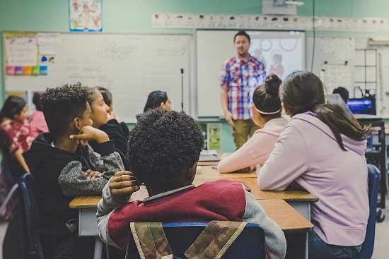 | Further details on exams and grades announced - GOV.UK  The exam regulator, Ofqual, and exam boards will work with teachers to provide grades to students whose exams have been cancelled this summer, following our actions to slow the spread of coronavirus.  www.gov.uk

We will keep you updated as we know more.
With every blessing for good health and peace of mind and heart.

Dr Dawn Casserly

