
Welcome to St Paul’s School for Girls, where our school mission states that we are all ‘made in the image and likeness of God’. Where ‘all are entitled in justice, to be given the opportunity to develop fully as persons and thus have equality of access to the curriculum’.

Many girls benefit from additional support during their learning journey and the information contained in this report aims to answer any questions you may have about this support.

In Birmingham there is help and advice about the services available for your child or young person from birth to 25 years with a special educational need or disability (SEND) from the local offer website:
https://www.localofferbirmingham.co.uk/
The parent and carer guide for SEND can be found at:
https://www.gov.uk/government/publications/send-guide-for-parents-and-carers

Our SEND Policy is included alongside this report on the school website

The SEND Department
Mrs A O’Neill (SENDCO)
Mrs P Campbell (Pupil Intervention and Progress, ASD support)
Mrs R Piggott (Pupil Intervention and Progress, SALT support)
Miss Dalziel (Pupil Intervention and Progress, ELSA)

What kind of SEND are provided for at St Paul’s?
We recognise that each pupil is unique, so we provide an education which enables all students to fulfil their potential; personally, socially, emotionally and academically.
We respect and accept the differing needs and strengths of all our students
We provide additional and/or different provision for a range of needs

(Code of Practice 2014)
NB re Physical Needs-As a school we are happy to discuss individual access requirements. However, St Paul’s was built in 1908 and we make reasonable adjustments in sympathy with the historical nature of the building.

How does St Paul’s know if my daughter needs extra help?
For new Year 7 pupils, this process begins once you have your offer of a place. We contact you with a link to answer a Microsoft Form about whether your daughter will need any extra support joining secondary school. All Year 7 pupils are offered a transition interview, those identified by the Microsoft Form will meet with Mrs O’Neill (SENDCO) to discuss what support will look like. We organise extra transition days and liaise with primary schools to gather as much information as possible.
For pupils already attending with us, the information can come for a variety of places:
- Concerns raised by parents, carers, teachers, outside agencies
- Limited or slow progress evidenced through school monitoring
- Concerns raised by reading tests
- Baseline data showing gaps in learning
If you think your daughter may have special needs or a disability you can approach school and speak to your daughter’s Head of Year or ask to speak to Mrs O’Neill the SENDCO.
You daughter will then be placed on the inclusion list.

How will St Paul’s support my daughter?
All pupils on the inclusion list have a one-page profile. A blank one is shown below:
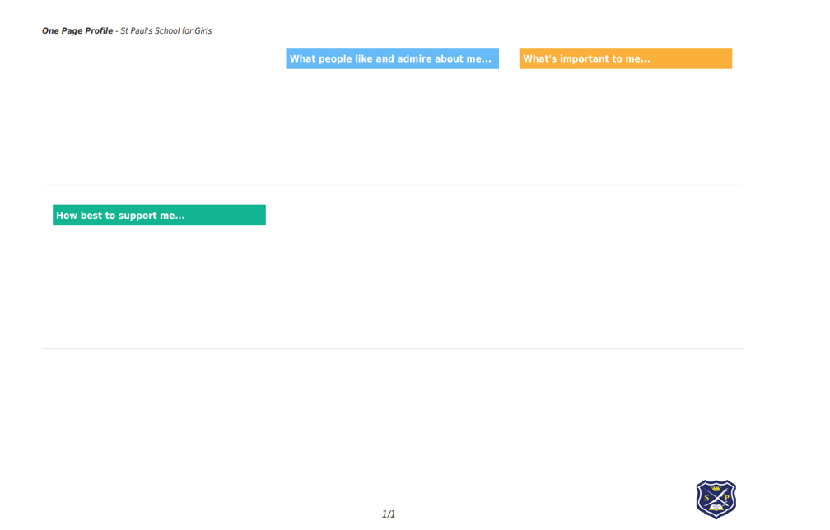
It has 3 sections: What people like and admire about me? What’s important to me? How best to support me? It also includes a picture of the pupil.
This one-page profile is written jointly with the pupil, parent and member of the SEND department. It outlines specific strategies that are used by subject teachers to support your daughter in the classroom. We update them as and when we learn something new and the SENDCO updates subject teachers.
Some pupils may benefit from some targeted interventions; these all take place between 8:50-9:20 in the mornings so that no lesson time is lost. These include; Lexia, Dynamo Maths, KS4 Study Support, Social Skills, reading, ELSA.
We also have access to specialist support service who work in partnership with us. These require additional parental consent.

Below summarises the specialist support services we currently work with…
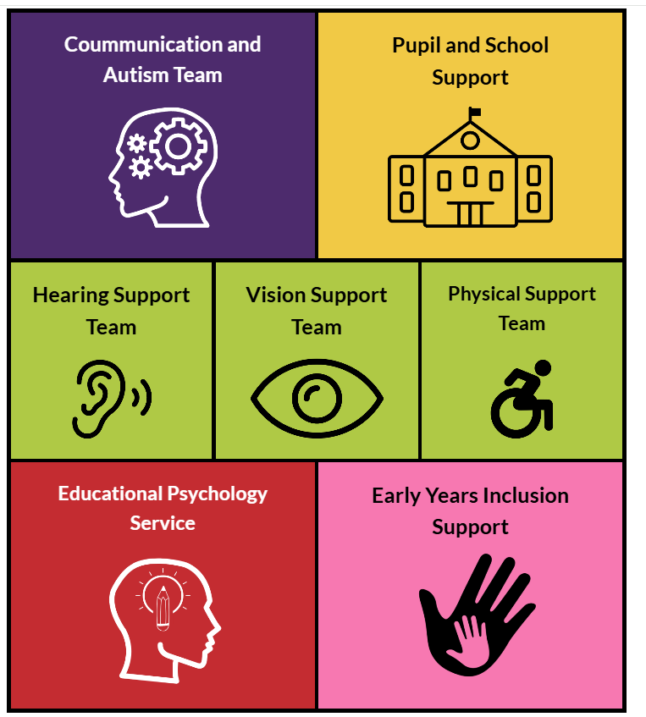
Private and NHS Speech and Language Therapists



Other professionals we may work with include: Forward Thinking Birmingham (Mental Health), COMPASS Birmingham, paediatricians, school nurse, social services and a careers advisor
All pupils on the inclusion list are offered termly reviews to monitor progress and discuss provision. Two of these meetings are held via Teams, where you will be given a 15-minute appointment which takes place with either the SENDCO or a PIP and your daughter. The third is offered as a parents evening slot.
At these review meetings, we will discuss what we have already tried, what we have learnt, what we are pleased about and what we are concerned about. It is an opportunity to update the one-page profile and set targets for the term ahead.
We follow the graduated approach, a four-part cycle of assess, plan, do, review summarised below

This discussion allows us to create a learning plan, which is reviewed at the next SEND review meeting.
If your daughter has an EHCP, in addition to these SEND review meetings you will have her annual review.
If despite all of this support then your daughter is still not making progress then we will have a discussion about whether an EHCP should be consider. The information regarding this is found below
https://www.localofferbirmingham.co.uk/education-health-and-care-plan/how-to-request-an-ehcp/

How will my daughter be supported in lessons?
First and foremost, this is by high quality first teaching from subject specialists in the classroom who provide differentiated and personalised support.
In some subject areas PIPs (teaching assistants) are deployed to support with small groups of children.
Your daughter will be taught in appropriate ability groups for Maths and English
Some students have access to assistive technology to support them in lesson including laptops and reader pens.
Some students may also require access arrangements for exams such as 25% extra time, readers, rest breaks, smaller room as and when we see fit in accordance with JCQ regulations.




How will I know if my daughter is making progress?

Each year pupils take PPEs (mock examinations) and this is reported by whole school monitoring reports, this happens twice a year. You will also have the opportunity to speak with subject teachers at the annual parents evening. These are in addition to the termly SEND reviews previously mentioned.
If your daughter is awarded positive and negative logs, you are alerted via the Arbor app.

How will St Paul’s prepare and support my daughter when joining or transferring to a new school or post 16 provision?
Year 6 Transition
- Mrs Kinsella Head of Year 7, the Senior Leadership team and Mrs O’Neill the SENDCO visit Primary schools to meet with new students in the term before joining St Paul’s
- Pupils visit school for a transition day in July
- Pupils with specific needs may visit St Paul’s for extra sessions before the Year 6 Transition Day
- Girls coming alone from primary schools are also invited to an additional transition event

Mid-year Transition

- Mrs Canavan Deputy Head teacher coordinates pupil admissions during an academic year. Pupils will have the support of a ‘buddy’ within their tutor group, the support of their form tutor and Head of Year
- Information shared about any additional needs of pupils with staff.

Transition to post 16 provision or university

- Girls are supported with a careers interview in Y11
- The girls are supported to complete application forms and with a transition interview to discuss their post 16 plans
- Girls with an EHCP receive guidance from a carers advisor during their annual reviews and the SENDCO supports liaising with colleges

- Girls in Year 12 and 13 are supported through the UCAS application process
- Girls are signposted to support services within universities and colleges.

How are the school’s resources allocated and matched to children’s special educational needs?
- There is a notional SEND budget which is allocated to St Paul’s school each financial year. This money is used to provide additional support and resources according to individual pupil needs
- Additional support or resources may be allocated to your daughter following an assessment by the SENDCO or following the recommendation of an outside agency
- Funding may be used for specialist support e.g. Speech and Language therapy
- Pupil Premium money may also be used to support your daughter’s learning
How is the decision made about what additional support my daughter will receive?
- All pupils are supported primarily through quality first teaching
- If a pupil makes less than expected progress additional support to help close the gaps is put in place. This support may be through targeted interventions or on a 1:1 basis or in a small group
- Parents will be notified of any additional support which their daughter receives
- The decision regarding support is jointly taken by form teachers, subject teachers, Head of Year and the SENDCO.
We aim to work together with pupil, parents and as a school to make decisions to support your daughter.
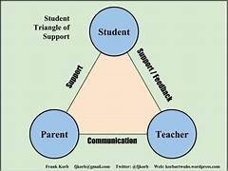

What do I do if I have a complaint about the provision offered to my daughter?
As a school we encourage regular, open and honest conversations between staff, parents/careers and the girls. If you are unhappy about the provision made for your daughter
Contact Mrs O’Neill the SENDCO, Mrs Canavan the Deputy Head Teacher or Dr Casserly the Head teacher who will work collaboratively with families to resolves any difficulties.
If you still have concerns contact Mrs Hodgson the SEND governor, her contact details are available from reception on request.

Who can I contact for further information?

If you wish to discuss your daughter’s learning please contact-

Your daughter’s Head of Year and their form teacher
Mrs O’Neill the SENDCO- aoneill@stpaulgl.bham.sch.uk
Mrs Hodgson the SEND governor via the school office

Please contact the school office to make an appointment 0121 454 0895
enquiries@stpaulgl.bham.sch.uk

