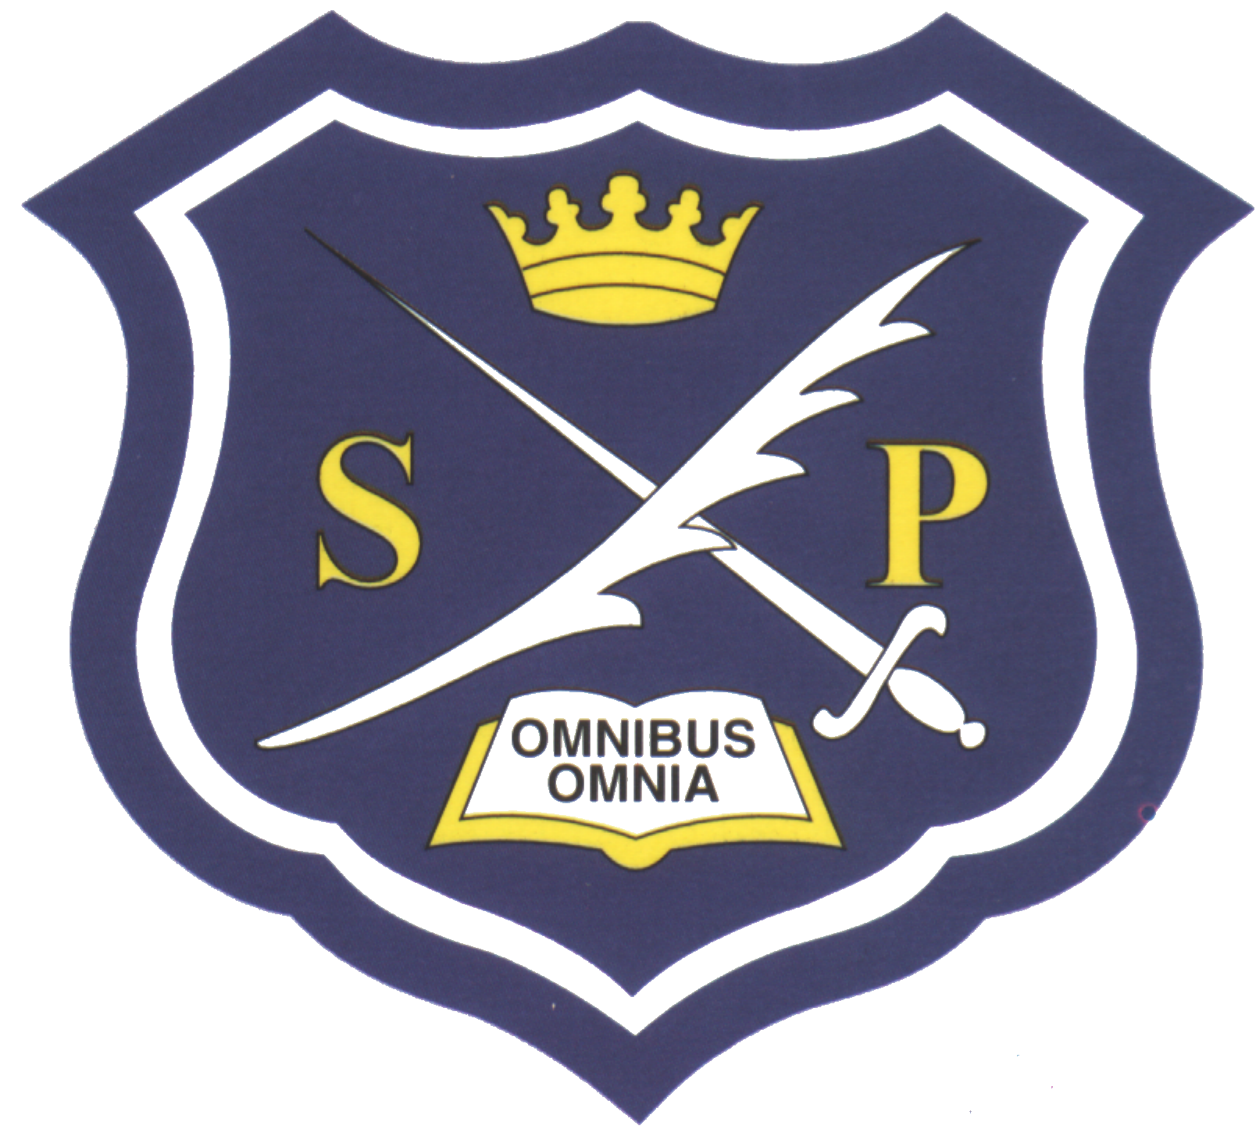

Are you getting your
Free School Meal
entitlement?

Are you getting your Free Bus Pass?
Are you getting your £25 uniform allowance?

Dear Parent/Guardian
We want to make sure that we are providing your child with the best education and support we can. Healthy school food has obvious health benefits and can help pupils establish healthy habits for life. Healthy school food can also help to improve pupils’ readiness to learn.
Families who receive certain benefits may be eligible for free school meals. Your child is eligible for free school meals if you are in receipt of one of the following benefits:
- Universal Credit with an annual net earned income of no more than £7,400.
- Income Support
- Income-based Jobseeker’s Allowance
- Income-related Employment and Support Allowance
- Support under Part 6 of the Immigration and Asylum Act 1999
- The guarantee element of Pension Credit
- Working Tax Credit run-on (paid for the four weeks after you stop qualifying for Working Tax Credit)
- Child Tax Credit (with no Working Tax Credit) with an annual income of no more than £16,190
Registering for free meals could entitle you to £25 towards your daughter’s uniform on production of a receipt and a free bus pass. Please collect a bus pass application from Reception, complete and return it to us.
It could also raise an extra £900 for your child’s secondary school, to fund valuable support like extra tuition, additional teaching staff or after school activities. This additional money is available from central government for every child whose parent is receiving one of the benefits listed above.

St Paul’s School for Girls Free School Meal Application Form

Daughter(s) Name(s)
_______________________________________________________ FORM ______

_______________________________________________________ FORM ______

-------------------------------------------------------------------------------------------- FORM ----------

Mother’s Name:  Please print | Father’s Name:  Please print
Address: | Address:
Date of Birth: | Date of Birth:
National Insurance Number  (or NASS Reference Number) | National Insurance Number  (or NASS Reference Number)

How the information in this form will be used?

The information you provide in this form will be used by St Paul’s School for Girls to confirm receipt of one of the listed welfare benefits through the Inland Revenue checking service.

You only need to complete this form once and it will last for the duration of your child’s time at their current school. You should contact the school or local authority if you have a change in financial circumstances.

St Paul’s School for Girls will process (collect, store and use) the information you provide in a manner compatible with EU’s General Data Protection Regulation (GDPR), we will endeavor to keep your information accurate and up-to-date, and not keep it longer than is necessary.

Our aim is not to be intrusive, and we undertake not to ask irrelevant or unnecessary questions.

Signed: ……………………………………………………. Date: …………………………….
Parent/Guardian

Print name: ……………………………………………………………

